Overview table
Figma link: https://www.figma.com/design/b7Tv5KsiQLPklQhEuYXoOK/VaxiFlow?node-id=0-1&p=f&t=IsQUf3dnXAZyU4MG-0

Page | Description | Mapped FPA
1: Login | Authentication Form | Validate Credentials (EI)
2: Dashboard | Overview of shipments and alerts | View active shipments and alerts (EQ)
3-10, 17-19: Shipment | Multiple functions under one shipment header | Create new shipments or edit existing ones(EQ, EI), Temperature Excursions details (EO)
11-12: Vaccine rules | Table for vaccine rule | Create new rules or edit current rules (EI, EQ)
13: Reports | Table for finished shipment | View the status of boxes during shipment and print the report (EQ, EO)
14: Audit log | Complete history for all processes | View the history of all shipments start to finish (EQ)
15: Users and Roles | Registration form | View and add new administrators (EQ, EI)
16: Temperature simulator | Testing before integration with physical boxes | Add temperature information to the database directly (ILF)
20-22: Cold Box | Cold box details | View status, details and add new cold boxes

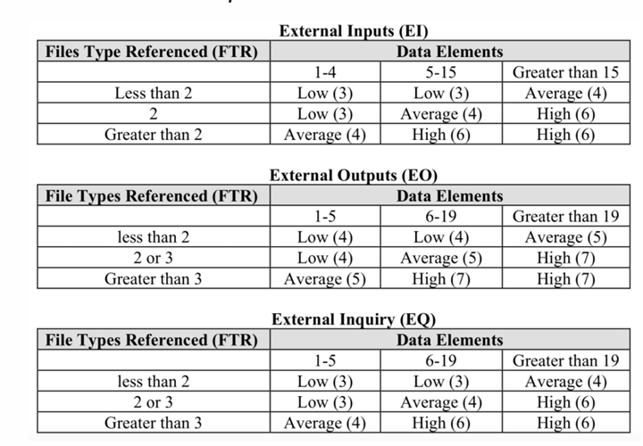

FTR Table 1 (Dashboard, Vaccine Rules, Reports, Audit log, User and Roles, Temperature Simulator, Cold Box Units)

Source Page | Elementary Process | Type | FTRs (Count & Names) | DETs (Count & Key Fields) | Complexi-ty | UFP
02 Dashboard | View active shipments and excursion alerts | EQ | 1  (Shipment) | 6  (Shipment ID, Route Name, Stops counts, Box ID, Box Count, Box Status) | Low | 3
03 Shipment List | View all shipments | EQ | 1  (Shipment) | 7  (Shipment ID, Route Name, Stops Count, Box Count, Attention, Departure, Shipment Status) | Low | 3
04 Create Shipment  10 Edit Shipment | Create a new shipment | EI | 1  (Shipment) | 7  (Shipment ID, Driver, Departure, Route, Stops, Contact, Box ID) | Low | 3
05 Active shipment monitoring | View shipment route and boxes | EQ | 2  (Shipment, Cold Box) | 7  (Shipment ID, Vaccine Name, Stop Name, Box ID, Sensor ID, Temperature, Box Status) | Average | 4
06 Temperature Alert | View detail of the compromised box | EO | 2  (Shipment, Cold Box) | 9  (Shipment ID, Vaccine Name, Stop Name, Contact, Box ID, Sensor ID, Temperature, Peak, Excursion Duration) | Average | 5
07 Offline pending sync | View boxes that are yet to be online | EQ | 2  (Shipment, Cold Box) | 6  (Shipment ID, Vaccine Name, Stop Name, Box ID, Temperature, Box Status) | Average | 4
08 Complete Shipment handover | Update delivered boxes at a stop | EI | 1  (Shipment) | 5  (Shipment ID, Stop Name, Receiving Staff, Handover timestamp, Note) | Low | 3
09 Shipment Details History | View detail of previous shipments | EO | 2  (Shipment, Cold Box) | 11  (Shipment ID, Stop Name, Handover timestamp, Shipment Status, Box ID, Sensor ID, Temperature, Min Temp, Max Temp, Excursion, Timestamp) | Low | 4
11 Vaccine Rules List | View active vaccine rules | EQ | 1 (Vaccine Rule) | 6  (Name, Min temp, Max temp, Allowed excursion, Author, Status) | Low | 3
12 Create Edit Vaccine Rules | Create a new vaccine rule | EI | 1  (Vaccine Rule) | 4  (Name, Min temp, Max temp, Allowed excursion) | Low | 3
13 Reports | View incident reports | EQ | 1  (Report) | 6  (Shipment ID, Stop name, Box ID, Status, Excursion timestamp) | Low | 3
14 Audit Logs | View shipment handling, assigned units and notification delivery | EQ | 1  (Audit) | 5  (Timestamp, User, Action, Target ID, Description) | Low | 3
15 User and Roles | View active users | EQ | 1  (User) | 4  (Name, Email, Role, Status) | Low | 3
15 User and Roles | Add a new user or edit an existing user | EI | 1  (User) | 3  (Name, Email, Role) | Low | 3
16 Temperature Simulator | View current temperature | EQ | 1  (Box) | 2  (Temperature, Timestamp) | Low | 3
16 Temperature Simulator | Send temperature | EI | 2  (Shipment, Box) | 4  (Shipment ID, Stop Name, Box ID, Temperature) | Low | 3
20 Cold Box Units | View available cold boxes and their statuses | EQ | 2  (Cold Box, Shipment) | 5  (Box ID, Sensor ID, Manufactured Date, Status, Assigned shipment) | Low | 3
21 Register Cold Box Unit | Register a new box or edit an existing box | EI | 1  (Cold Box) | 6  (Box ID, Sensor ID, Manufactured Date, Registered Date, Status, Note) | Low | 3
22 Cold Box Unit Details | View details of a cold box | EQ | 2  (Shipment) | 10  (Box ID, Sensor ID, Manufactured Date, Registered Date, Status, Temperature, Shipment ID, Assigned Date, Stop Name, Shipment Status) | Average | 4
UFP |  |  |  |  |  | 63
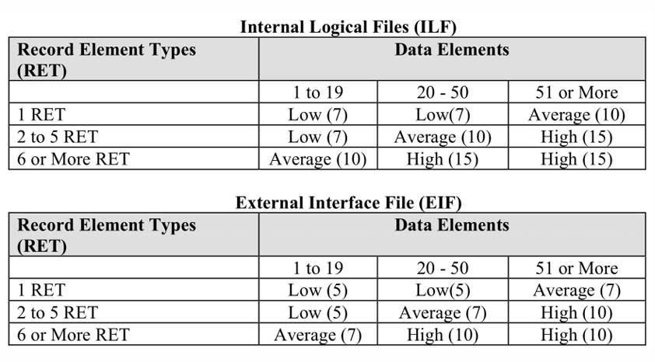

RET Table
Logical File Name | Type | RETs (Count & Subgroups) | DETs (Count & Key Fields) | Complexity | UFP
Shipment | ILF | 1 | id, driver, departure, route, stops, contact, box_id | Low | 7
Cold Box | ILF | 2  Boxes, Vaccine Rules | id, sensor_id, manufactured_date, registered_date, status, notes, vaccine_name, max_temp, min_temp, allowed_excursion, author | Low | 7
Audit | ILF | 1 | timestamp, user, action, target, details | Low | 7
User | ILF | 1 | name, email, role, status | Low | 7
UFP |  |  |  |  | 28

Value Adjustment Factor
# | General System Characteristic (GSC) | Rating (0–5) | Cold-Chain Vaccine System Justification
1 | Data Communications | 4 | Telemetry ingestion from remote IoT sensor devices over networks
2 | Distributed Data Processing | 3 | Ingestion pipeline and alert evaluation operate independently from the frontend presentation layer and central DB.
3 | Performance | 4 | Immediate response times are critical; excursion alerts must fire within seconds to log time accurately
4 | Heavily Used Configuration | 2 | Telemetry ingestion requires persistent server resources.
5 | Transaction Rate | 4 | Continuous, high-frequency time-series data streams (periodic temperature, battery, and location pings per box).
6 | Online Data Entry | 4 | Operations combine automated sensor payloads with web-based dispatch configurations and threshold setup forms.
7 | End-User Efficiency | 4 | Live monitoring dashboards, automated visual alerts, audible cues, and single-click incident acknowledgement.
8 | Online Update | 5 | Critical tables (Sensor_Logs, Excursion_Alerts, Shipment_Status) update instantly without batch delays.
9 | Complex Processing | 4 | Real-time threshold evaluation, temperature boundary checks and excursion duration
10 | Reusability | 2 | Standard modular frontend components and backend services built for internal application scope.
11 | Installation Ease | 2 | Centralized web application deployment; sensor pairing handled via standard device provisioning.
12 | Operational Ease | 4 | Comprehensive automated audit trails ("everything must be logged"), self-recovering streams, and automated health checks.
13 | Multiple Sites | 2 | Deployed only on selected routes as a pilot
14 | Facilitate Change | 3 | Configurable temperature thresholds, custom contact notification, and adaptable cold-chain product profiles.

Cost Estimation
TDI = 4 + 3 + 4 + 2 + 4 + 4 + 4 + 5 + 4 + 2 + 2 + 4 + 4 + 3 = 48

VAF = 0.65 + (0.01 x 48) = 1.13

AFP = (28 + 63) x 1.13 = 102.83

Productivity = 10 FP per person-month

Efforts = 102.83 % 10 = 10.283 person-months

Assume labor cost = $2,940 per person-month (Blended rate)

Title | Cost
Total labour cost | $30,232
Software licenses | $600
Server hosting (AWS 1-year) | $700
Overhead | $9,069
Project oversight and direction | $7,000
30 monitoring boxes for pilot | $3,000
Total | $50,601

